***Phase 06- vipers***

***Screen shots of succesfull data loading***

**For Service table:**

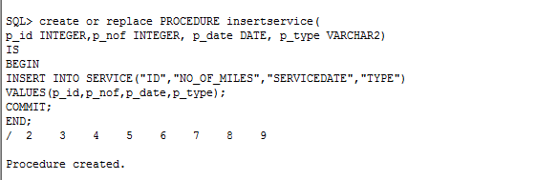

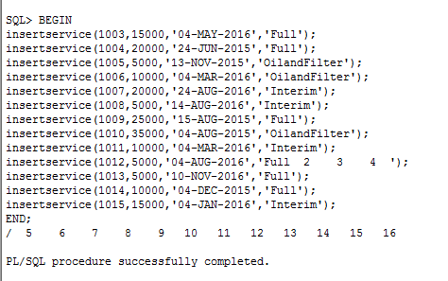

**For CAR table:**

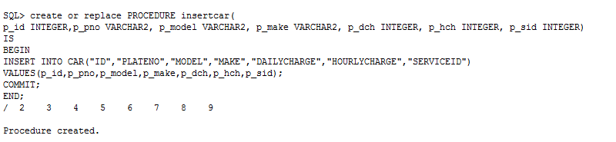

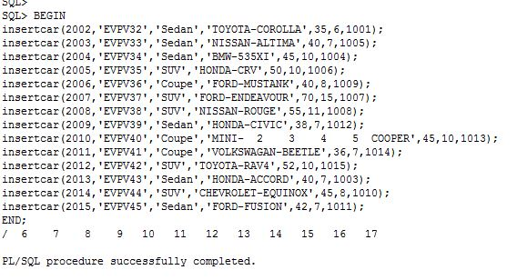

**For CARCODE table:**

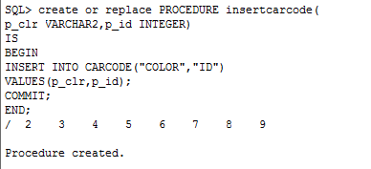

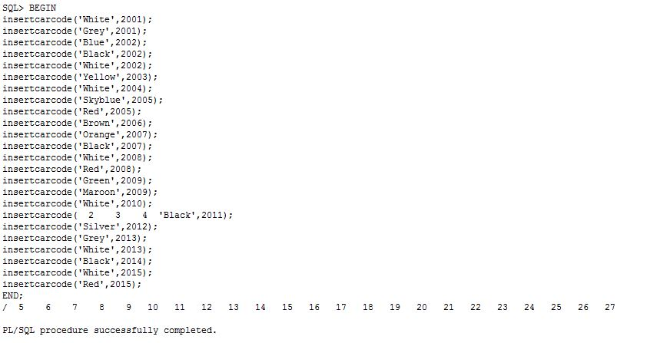

**For CARRENTAL table:**

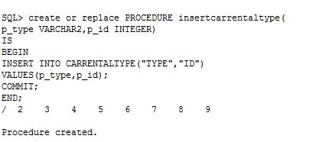

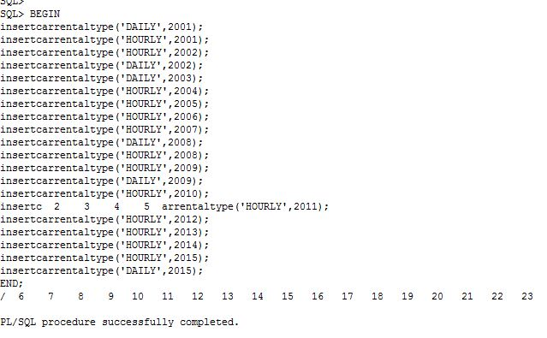

**For INSURANCE table:**

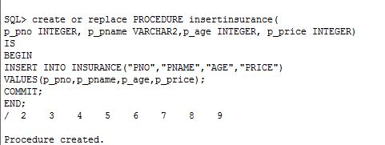

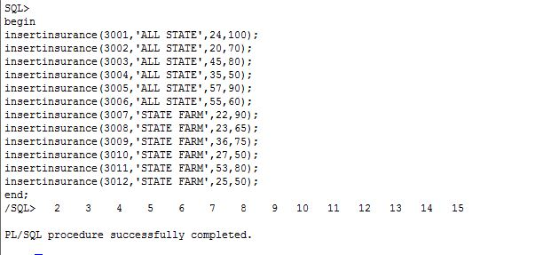

**For OFFERS table:**

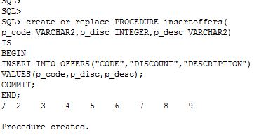

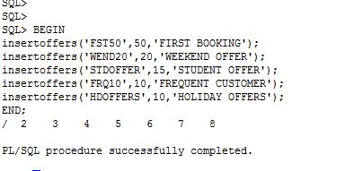

**For EMPLOYEE table:**

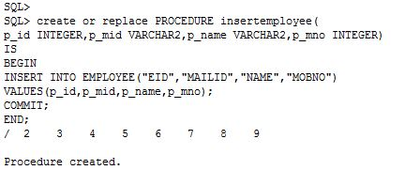

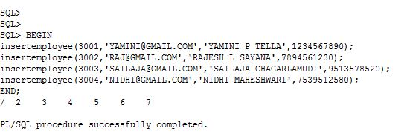

**For CUSTOMER table:**

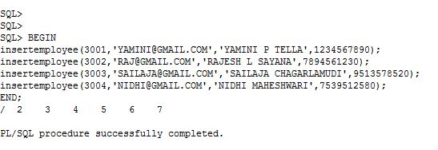

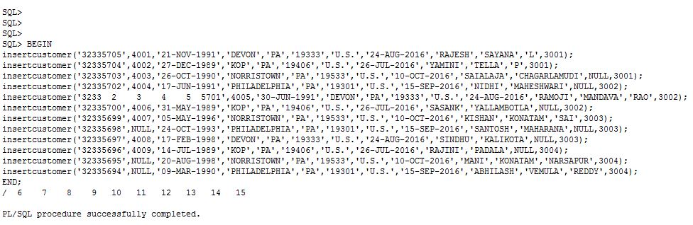

**For BOOKINGHISTORY table:**

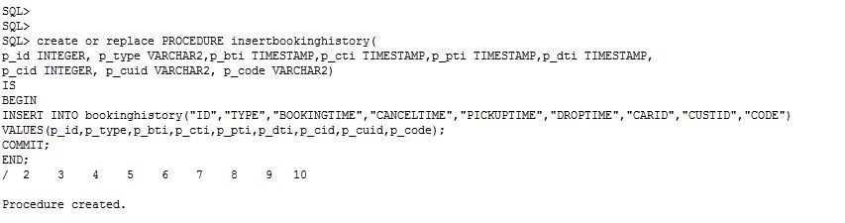

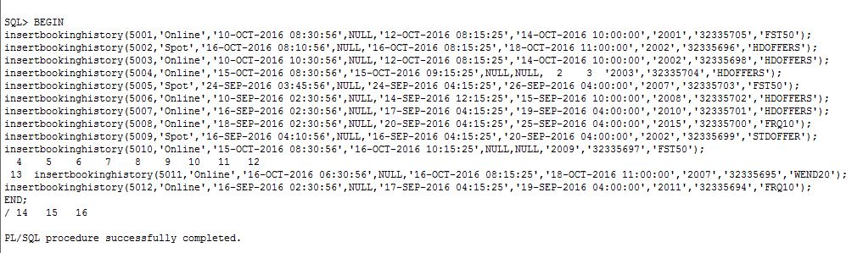

**For CHOOSES table:**

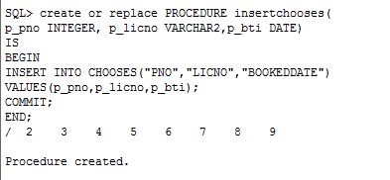

**For OFFERELIGIBILITY table:**

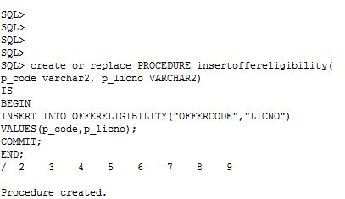

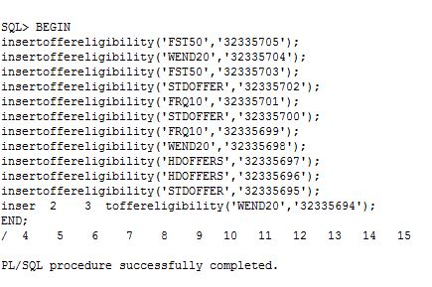

***PLSQL scripts for loading the schema instance***

FOR SERVICE TABLE:

create or replace PROCEDURE insertservice(p_id INTEGER,p_nof INTEGER, p_date DATE, p_type VARCHAR2)

IS

BEGIN

INSERT INTO SERVICE("ID","NO_OF_MILES","SERVICEDATE","TYPE")

VALUES(p_id,p_nof,p_date,p_type);

COMMIT;

END;

/

Tested normal insert:

BEGIN

insertservice(1001,5000,'04-MAR-2015','Full');

insertservice(1002,4000,'05-NOV-2015','Full');

insertservice(1016,16000,'11-Nov-2015','Interim');

END;

/

BEGIN

insertservice(1003,15000,'04-MAY-2016','Full');

insertservice(1004,20000,'24-JUN-2015','Full');

insertservice(1005,5000,'13-NOV-2015','OilandFilter');

insertservice(1006,10000,'04-MAR-2016','OilandFilter');

insertservice(1007,20000,'24-AUG-2016','Interim');

insertservice(1008,5000,'14-AUG-2016','Interim');

insertservice(1009,25000,'15-AUG-2015','Full');

insertservice(1010,35000,'04-AUG-2015','OilandFilter');

insertservice(1011,10000,'04-MAR-2016','Interim');

insertservice(1012,5000,'04-AUG-2016','Full');

insertservice(1013,5000,'10-NOV-2016','Full');

insertservice(1014,10000,'04-DEC-2015','Full');

insertservice(1015,15000,'04-JAN-2016','Interim');

END;

/

==============================================================================

FOR CAR TABLE:

create or replace PROCEDURE insertcar(p_id INTEGER,p_pno VARCHAR2, p_model VARCHAR2, p_make VARCHAR2, p_dch INTEGER, p_hch INTEGER, p_sid INTEGER)

IS

BEGIN

INSERT INTO CAR("ID","PLATENO","MODEL","MAKE","DAILYCHARGE","HOURLYCHARGE","SERVICEID")

VALUES(p_id,p_pno,p_model,p_make,p_dch,p_hch,p_sid);

COMMIT;

END;

/

BEGIN

insertcar(2001,'EVPV31','SUV','NISSAN-MURANO',60,12,1002);

insertcar(2002,'EVPV32','Sedan','TOYOTA-COROLLA',35,6,1001);

insertcar(2003,'EVPV33','Sedan','NISSAN-ALTIMA',40,7,1005);

insertcar(2004,'EVPV34','Sedan','BMW-535XI',45,10,1004);

insertcar(2005,'EVPV35','SUV','HONDA-CRV',50,10,1006);

insertcar(2006,'EVPV36','Coupe','FORD-MUSTANK',40,8,1009);

insertcar(2007,'EVPV37','SUV','FORD-ENDEAVOUR',70,15,1007);

insertcar(2008,'EVPV38','SUV','NISSAN-ROUGE',55,11,1008);

insertcar(2009,'EVPV39','Sedan','HONDA-CIVIC',38,7,1012);

insertcar(2010,'EVPV40','Coupe','MINI-COOPER',45,10,1013);

insertcar(2011,'EVPV41','Coupe','VOLKSWAGAN-BEETLE',36,7,1014);

insertcar(2012,'EVPV42','SUV','TOYOTA-RAV4',52,10,1015);

insertcar(2013,'EVPV43','Sedan','HONDA-ACCORD',40,7,1003);

insertcar(2014,'EVPV44','SUV','CHEVROLET-EQUINOX',45,8,1010);

insertcar(2015,'EVPV45','Sedan','FORD-FUSION',42,7,1011);

END;

/

==============================================================================

FOR CARCODE TABLE:

create or replace PROCEDURE insertcarcode(p_clr VARCHAR2,p_id INTEGER)

IS

BEGIN

INSERT INTO CARCODE("COLOR","ID")

VALUES(p_clr,p_id);

COMMIT;

END;

/

BEGIN

insertcarcode('White',2001);

insertcarcode('Grey',2001);

insertcarcode('Blue',2002);

insertcarcode('Black',2002);

insertcarcode('White',2002);

insertcarcode('Yellow',2003);

insertcarcode('White',2004);

insertcarcode('Skyblue',2005);

insertcarcode('Red',2005);

insertcarcode('Brown',2006);

insertcarcode('Orange',2007);

insertcarcode('Black',2007);

insertcarcode('White',2008);

insertcarcode('Red',2008);

insertcarcode('Green',2009);

insertcarcode('Maroon',2009);

insertcarcode('White',2010);

insertcarcode('Black',2011);

insertcarcode('Silver',2012);

insertcarcode('Grey',2013);

insertcarcode('White',2013);

insertcarcode('Black',2014);

insertcarcode('White',2015);

insertcarcode('Red',2015);

END;

/

==============================================================================

FOR CARRENTALTYPE TABLE:

create or replace PROCEDURE insertcarrentaltype(p_type VARCHAR2,p_id INTEGER)

IS

BEGIN

INSERT INTO CARRENTALTYPE("TYPE","ID")

VALUES(p_type,p_id);

COMMIT;

END;

/

BEGIN

insertcarrentaltype('DAILY',2001);

insertcarrentaltype('HOURLY',2001);

insertcarrentaltype('HOURLY',2002);

insertcarrentaltype('DAILY',2002);

insertcarrentaltype('DAILY',2003);

insertcarrentaltype('HOURLY',2004);

insertcarrentaltype('HOURLY',2005);

insertcarrentaltype('HOURLY',2006);

insertcarrentaltype('HOURLY',2007);

insertcarrentaltype('DAILY',2008);

insertcarrentaltype('HOURLY',2008);

insertcarrentaltype('HOURLY',2009);

insertcarrentaltype('DAILY',2009);

insertcarrentaltype('HOURLY',2010);

insertcarrentaltype('HOURLY',2011);

insertcarrentaltype('HOURLY',2012);

insertcarrentaltype('HOURLY',2013);

insertcarrentaltype('HOURLY',2014);

insertcarrentaltype('HOURLY',2015);

insertcarrentaltype('DAILY',2015);

END;

/

==============================================================================

FOR INSURANCE TABLE:

create or replace PROCEDURE insertinsurance(

p_pno INTEGER, p_pname VARCHAR2,p_age INTEGER, p_price INTEGER)

IS

BEGIN

INSERT INTO INSURANCE("PNO","PNAME","AGE","PRICE")

VALUES(p_pno,p_pname,p_age,p_price);

COMMIT;

END;

/

begin

insertinsurance(3001,'ALL STATE',24,100);

insertinsurance(3002,'ALL STATE',20,70);

insertinsurance(3003,'ALL STATE',45,80);

insertinsurance(3004,'ALL STATE',35,50);

insertinsurance(3005,'ALL STATE',57,90);

insertinsurance(3006,'ALL STATE',55,60);

insertinsurance(3007,'STATE FARM',22,90);

insertinsurance(3008,'STATE FARM',23,65);

insertinsurance(3009,'STATE FARM',36,75);

insertinsurance(3010,'STATE FARM',27,50);

insertinsurance(3011,'STATE FARM',53,80);

insertinsurance(3012,'STATE FARM',25,50);

end;

/

==============================================================================

FOR OFFERS TABLE:

create or replace PROCEDURE insertoffers(

p_code VARCHAR2,p_disc INTEGER,p_desc VARCHAR2)

IS

BEGIN

INSERT INTO OFFERS("CODE","DISCOUNT","DESCRIPTION")

VALUES(p_code,p_disc,p_desc);

COMMIT;

END;

/

BEGIN

insertoffers('FST50',50,'FIRST BOOKING');

insertoffers('WEND20',20,'WEEKEND OFFER');

insertoffers('STDOFFER',15,'STUDENT OFFER');

insertoffers('FRQ10',10,'FREQUENT CUSTOMER');

insertoffers('HDOFFERS',10,'HOLIDAY OFFERS');

END;

/

==============================================================================

FOR EMPLOYEE TABLE:

create or replace PROCEDURE insertemployee(

p_id INTEGER,p_mid VARCHAR2,p_name VARCHAR2,p_mno INTEGER)

IS

BEGIN

INSERT INTO EMPLOYEE("EID","MAILID","NAME","MOBNO")

VALUES(p_id,p_mid,p_name,p_mno);

COMMIT;

END;

/

BEGIN

insertemployee(3001,'YAMINI@GMAIL.COM','YAMINI P TELLA',1234567890);

insertemployee(3002,'RAJ@GMAIL.COM','RAJESH L SAYANA',7894561230);

insertemployee(3003,'SAILAJA@GMAIL.COM','SAILAJA CHAGARLAMUDI',9513578520);

insertemployee(3004,'NIDHI@GMAIL.COM','NIDHI MAHESHWARI',7539512580);

END;

/

==============================================================================

FOR CUSTOMER TABLE:

create or replace PROCEDURE insertcustomer(

p_licno VARCHAR2,p_mid INTEGER,p_dob DATE, p_ln1 VARCHAR2,p_state VARCHAR2,p_zip VARCHAR2,p_country VARCHAR2,

p_strdt DATE, p_fna VARCHAR2, p_lna VARCHAR2, p_mna VARCHAR2, p_eid INTEGER)

IS

BEGIN

INSERT INTO CUSTOMER("LICNO","MEMID","DOB","LINE1","STATE","ZIP","COUNTRY","START_DATE","FNAME","LNAME","MNAME","EID")

VALUES(p_licno,p_mid,p_dob,p_ln1,p_state,p_zip,p_country,p_strdt,p_fna,p_lna,p_mna,p_eid);

COMMIT;

END;

/

BEGIN

insertcustomer('32335705',4001,'21-NOV-1991','DEVON','PA','19333','U.S.','24-AUG-2016','RAJESH','SAYANA','L',3001);

insertcustomer('32335704',4002,'27-DEC-1989','KOP','PA','19406','U.S.','26-JUL-2016','YAMINI','TELLA','P',3001);

insertcustomer('32335703',4003,'26-OCT-1990','NORRISTOWN','PA','19533','U.S.','10-OCT-2016','SAIALAJA','CHAGARLAMUDI',NULL,3001);

insertcustomer('32335702',4004,'17-JUN-1991','PHILADELPHIA','PA','19301','U.S.','15-SEP-2016','NIDHI','MAHESHWARI',NULL,3002);

insertcustomer('32335701',4005,'30-JUN-1991','DEVON','PA','19333','U.S.','24-AUG-2016','RAMOJI','MANDAVA','RAO',3002);

insertcustomer('32335700',4006,'31-MAY-1989','KOP','PA','19406','U.S.','26-JUL-2016','SASANK','YALLAMBOTLA',NULL,3002);

insertcustomer('32335699',4007,'05-MAY-1996','NORRISTOWN','PA','19533','U.S.','10-OCT-2016','KISHAN','KONATAM','SAI',3003);

insertcustomer('32335698',NULL,'24-OCT-1993','PHILADELPHIA','PA','19301','U.S.','15-SEP-2016','SANTOSH','MAHARANA',NULL,3003);

insertcustomer('32335697',4008,'17-FEB-1998','DEVON','PA','19333','U.S.','24-AUG-2016','SINDHU','KALIKOTA',NULL,3003);

insertcustomer('32335696',4009,'14-JUL-1989','KOP','PA','19406','U.S.','26-JUL-2016','RAJINI','PADALA',NULL,3004);

insertcustomer('32335695',NULL,'20-AUG-1998','NORRISTOWN','PA','19533','U.S.','10-OCT-2016','MANI','KONATAM','NARSAPUR',3004);

insertcustomer('32335694',NULL,'09-MAR-1990','PHILADELPHIA','PA','19301','U.S.','15-SEP-2016','ABHILASH','VEMULA','REDDY',3004);

END;

/

==============================================================================

FOR BOOKINGHISTORY TABLE:

create or replace PROCEDURE insertbookinghistory(

p_id INTEGER, p_type VARCHAR2,p_bti TIMESTAMP,p_cti TIMESTAMP,p_pti TIMESTAMP,p_dti TIMESTAMP,

p_cid INTEGER, p_cuid VARCHAR2, p_code VARCHAR2)

IS

BEGIN

INSERT INTO bookinghistory("ID","TYPE","BOOKINGTIME","CANCELTIME","PICKUPTIME","DROPTIME","CARID","CUSTID","CODE")

VALUES(p_id,p_type,p_bti,p_cti,p_pti,p_dti,p_cid,p_cuid,p_code);

COMMIT;

END;

/

BEGIN

insertbookinghistory(5001,'Online','10-OCT-2016 08:30:56',NULL,'12-OCT-2016 08:15:25','14-OCT-2016 10:00:00','2001','32335705','FST50');

insertbookinghistory(5002,'Spot','16-OCT-2016 08:10:56',NULL,'16-OCT-2016 08:15:25','18-OCT-2016 11:00:00','2002','32335696','HDOFFERS');

insertbookinghistory(5003,'Online','10-OCT-2016 10:30:56',NULL,'12-OCT-2016 08:15:25','14-OCT-2016 10:00:00','2002','32335698','HDOFFERS');

insertbookinghistory(5004,'Online','15-OCT-2016 08:30:56','15-OCT-2016 09:15:25',NULL,NULL,'2003','32335704','HDOFFERS');

insertbookinghistory(5005,'Spot','24-SEP-2016 03:45:56',NULL,'24-SEP-2016 04:15:25','26-SEP-2016 04:00:00','2007','32335703','FST50');

insertbookinghistory(5006,'Online','10-SEP-2016 02:30:56',NULL,'14-SEP-2016 12:15:25','15-SEP-2016 10:00:00','2008','32335702','HDOFFERS');

insertbookinghistory(5007,'Online','16-SEP-2016 02:30:56',NULL,'17-SEP-2016 04:15:25','19-SEP-2016 04:00:00','2010','32335701','HDOFFERS');

insertbookinghistory(5008,'Online','18-SEP-2016 02:30:56',NULL,'20-SEP-2016 04:15:25','25-SEP-2016 04:00:00','2015','32335700','FRQ10');

insertbookinghistory(5009,'Spot','16-SEP-2016 04:10:56',NULL,'16-SEP-2016 04:15:25','20-SEP-2016 04:00:00','2002','32335699','STDOFFER');

insertbookinghistory(5010,'Online','15-OCT-2016 08:30:56','16-OCT-2016 10:15:25',NULL,NULL,'2009','32335697','FST50');

insertbookinghistory(5011,'Online','16-OCT-2016 06:30:56',NULL,'16-OCT-2016 08:15:25','18-OCT-2016 11:00:00','2007','32335695','WEND20');

insertbookinghistory(5012,'Online','16-SEP-2016 02:30:56',NULL,'17-SEP-2016 04:15:25','19-SEP-2016 04:00:00','2011','32335694','FRQ10');

END;

/

==============================================================================

FOR CHOOSES TABLE:

create or replace PROCEDURE insertchooses(

p_pno INTEGER, p_licno VARCHAR2,p_bti DATE)

IS

BEGIN

INSERT INTO CHOOSES("PNO","LICNO","BOOKEDDATE")

VALUES(p_pno,p_licno,p_bti);

COMMIT;

END;

/

BEGIN

insertchooses(3001,'32335705','10-OCT-2016');

insertchooses(3004,'32335704','15-OCT-2016');

insertchooses(3005,'32335703','24-SEP-2016');

insertchooses(3003,'32335702','10-SEP-2016');

insertchooses(3005,'32335701','16-SEP-2016');

insertchooses(3001,'32335700','18-SEP-2016');

insertchooses(3002,'32335704','15-OCT-2016');

insertchooses(3003,'32335703','24-SEP-2016');

insertchooses(3004,'32335702','10-SEP-2016');

insertchooses(3007,'32335699','16-SEP-2016');

insertchooses(3008,'32335698','10-OCT-2016');

insertchooses(3009,'32335697','15-OCT-2016');

insertchooses(3010,'32335696','16-OCT-2016');

insertchooses(3011,'32335695','16-OCT-2016');

insertchooses(3012,'32335694','16-SEP-2016');

END;

/

==============================================================================

FOR OFFERELIGIBILITY TABLE:

create or replace PROCEDURE insertoffereligibility(

p_code varchar2, p_licno VARCHAR2)

IS

BEGIN

INSERT INTO OFFERELIGIBILITY("OFFERCODE","LICNO")

VALUES(p_code,p_licno);

COMMIT;

END;

/

BEGIN

insertoffereligibility('FST50','32335705');

insertoffereligibility('WEND20','32335704');

insertoffereligibility('FST50','32335703');

insertoffereligibility('STDOFFER','32335702');

insertoffereligibility('FRQ10','32335701');

insertoffereligibility('STDOFFER','32335700');

insertoffereligibility('FRQ10','32335699');

insertoffereligibility('WEND20','32335698');

insertoffereligibility('HDOFFERS','32335697');

insertoffereligibility('HDOFFERS','32335696');

insertoffereligibility('STDOFFER','32335695');

insertoffereligibility('WEND20','32335694');

END;

/